**Ömer Oktay Gültekin**

**21901413**

**Question 1:**

**b.**

Keynes favored government spending over tax and transfer payments since as indicated in page 12 of the report, direct spending of the government stimulate the economy more than tax cuts and transfer payments. This is because the government spending directly affects the multiplier and has butterfly effect that encourage the private spending in Keynesian model. However, for T and TR, people may want to save part of them. Therefore, directly effecting part of the T or TR in the economy is smaller than G. Thus, G has a bigger multiplier than T and TR which makes Keynes prefer G.

However, in some cases like the epidemic, the economy may need liquidity and purchasing power of the people is decreased. People that got fired or get low-income has harsh times in extraordinary situations because they may not be able to save enough in normal times. In these cases, if targeted correctly, T and TR may stimulate the economy more than G would do. In other words, if people do not have money or needs more money for their priorities like food or health, the government spending may not encourage them to spend more on less priority products. The report supports this view. From the research of Chetty et al. 35 cents per dollar that is received from government spend in a month during the pandemic. Karget and Rajan also support this by showing 48% of the direct payments received are spent within two week. Chetty et al. also shows that relatively more many that is received were spend on food and other necessities during pandemic than 2001 and 2008 recessions.

On the other hand, in pandemic companies found themselves in a bad situation. Therefore, direct payments to them was more beneficial to them otherwise they get from government spending. Study by Bartik et al. shows that states that receive more Paycheck Protection Program (PPP) loans had smoother declines and faster recoveries. Also, other study by Autor et al. shows these aids increase employment in affected firms by 7.5%. Another study conducted by JPMorgan Chase & Company shows that firms aids reduce unemployment by 10% but it does not decrease the spending of the unemployed population who receives UI benefits, it also increase by 10%. Therefore, even the lesser unemployed population were able to spend more because they need to. Overall, they cannot imagine a worser scenerio to save than the pandemic. Therefore, unemployed people who must live in the present were especially eager to spend their money.

**c.**

**1)**

According to the lifetime hypothesis of consumption, people spends their money according to their expected lifetime income and plan their consumption by their expected average income (permanent income hypothesis). For example, as I worked part time in a company, I received minimum wage that was determined by the government. I am eager to spend that money because I know that as a software engineer, I will earn much more than minimum wage in the future. Therefore, I do not sacrifice my life standart to save this money. I was already determining the money I need to maintain my life standart and this is what the lifetime hypothesis of consumption is about. Therefore, temporary tax cuts is seen as one time bonus by the individuals, and they are not eager to spend it since they already satisfies their life standart. According to them, it is more logical to save this money to maintain that life standart in retirement that their income will be low. Therefore, the multiplier of the temporary tax cuts will be small since much of that money will most likely be saved by individuals. However, the statement given in the question may not always hold especially for low and middle-income individuals and in extraordinary situations like pandemic that they are below their expected lifetime standart.

**2)**

According to page 17 of the report, tax cuts has smaller multipliers but depends on income level of individuals.

According to page 17 of the report, individuals that are liquidity constrained and are willing to spend more than their income but cannot borrow, will much more likely spend what they receive without saving. The probability of spending a larger share of the any tax cut is higher for lower- and middle-income taxpayers for these circumstances together with others. According to CBO data, for the received money from the refundable Making Work Pay tax credit, and from the other tax cuts, people from low- and middle-income have multipliers of 0.7 to 0.9, while people with high-income had multiplier of 0.35.

According to page 17 of the report, sometimes temporary tax cuts may stimulate the economy more than permanent ones, like temporary investment subsidy or a sales tax holiday.

The permanent income theory only holds when individuals can predict their income, thus having stable income. Otherwise, as indicated in the above evidence, individuals with liquidity problems or want higher life standarts most likely spend their money when they get additional “one-time bonus”. Intuitively, we can see this situation in real life. Unfortunately, so many people in Turkey earns a money that they want to earn and live a lower standart life. Therefore, when they get money, they cannot think much about the future and wants to go on the holiday, to live even at least a couple of days in their dream life standart by accepting a year long of burden this holiday brought to them.

Also temporary tax cuts may sometimes be more effective than permanent ones when people get a sense of opportunity door opens. The evidences from the report given above are self explanatory. Therefore, I want to give a real-life example of this situation. Especially nowadays in Turkey, government argue to cut taxes from automobile industry which will increase the sales of the cars since people will think that it is an opportunity. It is because in the future, the prices of cars may not be at this level, therefore, even if I do not need it, I can buy a car or upgrade my current one. In worse, I can sell it in second-hand market. Another example would be the tax cut in foods that make people including low-income ones stock them in their house with the sense of “opportunity”. In these exceptional cases, aggregate demand will increase more than permanent-income hypothesis expects.

**d.**

The report approach the issue as one of uncertainty. In the page 9 the report, the report suggests depending on the caution level of the consumers, when the restrictions loosen, there may be demand boom by the money that consumers may save during the pandemic since the future was uncertain and when the pandemic will finish was not known. This part of the report suggests that people may save more because of uncertainty in the pandemic and delay some of their secondary demands. This behaviour of saving to spend more when there is freedom also complies with permanent-income hypothesis since during the pandemic people had lesser life-standart than they expected to have and saved more than they expected to. Therefore, when the life goes normal, it is logical to spend excess saving to compensate the decrease in life-standart during the pandemic.

Also in page 17 of the report, it says that even if there is high savings rate in April, much of the direct payments received from the government were spent during pandemic but saving ones may be saved by some individuals to spend once they become more confident and restrictions gone.

**e.**

Discretionary fiscal policy is the direct changes made by government in its spending or taxation policy to achieve some macroeconomic goal, such as reducing inflation or increasing employment rate. This policy requires specifics actions and steps. On the other hand, non-discretionary fiscal policy tools, in other words automatic stabilizers, refers to automatic response from the existing government policies that do not require any additional action such as unemployment insurance, welfare programs, and progressive income taxation.

The increase in unemployment benefit payments made by the US government during the pandemic is an example of both discretionary and non-discretionary fiscal policy tools. The non-discretionary part of this increase is the fact that the unemployment insurance program is an automatic stabilizer, which means that when there is a rise in unemployment, the program automatically provides financial assistance to individuals who have lost their jobs. Therefore, the increase in unemployment benefit payments during the pandemic was a non-discretionary response to the rise in unemployment caused by the pandemic.

On the other hand, the discretionary part of the increase was the fact that, as indicated in page 3 of the report, the US government deliberately increased the unemployment benefit payments as part of the CARES Act passed in March 2020. This discretionary policy was designed to provide additional financial support to individuals who lost their jobs due to the pandemic and to stimulate consumer spending. The increase in unemployment benefit payments was part of a larger fiscal stimulus package aimed at boosting aggregate demand and supporting economic growth during the pandemic-induced recession.

Overall, while both automatic stabilizers and discretionary fiscal policy tools can be used to stabilize the economy, the key difference between them is the extent to which they require deliberate government action. Automatic stabilizers respond to changes in the economy automatically, while discretionary policies require government action.

**Question 2:**

**a.**

LRAS is determined by potential GDP which in turn is determined by the number of workers, the capital stock, and the available technology. At potential GDP, all firms operate in their potential capacity and everyone who wants to work except for structurally and frictionally employed have a job. Therefore, the price level can’t affect the potential GDP. Fluctuations in price level affects the aggregate supply in the short run but not in the long run. Only price level change affects the position of the equilibrium in the long run which become e2 from e0 in the graph of part d.

The position of the LRAS is determined by potential GDP and in graph we can see that e0 is a potential GDP point since it is the stable point for the economy by being the intersection of the AD and SRAS. In short, stable point is what the economy will be in the long run since it will fluctuate around this point if we think recession and growth cycles.

**b.**

An example of a demand shock would be the effect of the pandemic on the tourism industry. As pandemics occur, people cancelled their reservations at hotels etc. and were even restricted from going outside by authorities. Therefore, tourism industry in pandemy experience a huge negative demand shock which later tried to be balanced by the authorities who pretends there is no disease in summer months to be able to encourage people to go vacations.

In this period, some of the hotels that cannot bear the negative demand shock were closed and open ones needed to lower price levels to be able to attract people with prices that they won’t see at normal times. Less people chose to go on vacation and the price of the chosen vacations were low resulting in the real GDP being lower in the short run.

**c.**

The decrease in aggregate demand causes reduction ­in the sales of the firms. As real GDP decreases from its potential level and firms become only able to sell their products from the lower prices, the profit of the firms are decreased which results in firms to layoff some workers. Less products are being able to sell at a lower price, in other words, less demand is satisfied by less supply make a shift from e0 to e1 in the short run. The economy is in recession.

However, e1 is only a SR equilibrium since the self-adjustment process (automatic mechanism) in the long run is explained in part d in detail.

**d.**

Increase in unemployment and power of money make workers willing to accept lower wages. Firms become more willing to accept lower prices due to low demand and low wages which results in SRAS0 curve to shift right in graph (SRAS2 line). The economy come back to long-run equilibrium (e2). Note that this adjustment process may take several years. Therefore, in the long run, only the price level is changed.

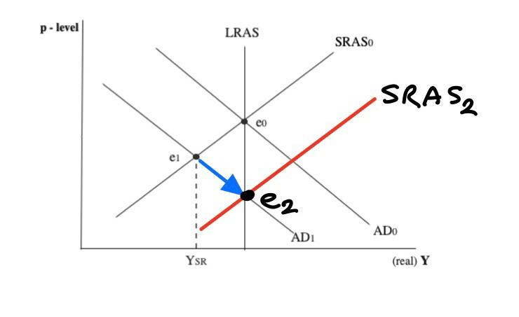

**e.**

Increasing G has a direct effect on aggregate demand since G is a component of aggregate demand. Therefore, increasing G directly increase Real GDP, price level and aggregate demand which shift aggregate demand curve from AD1 to AD0 . When aggregate demand is increasing, increase the firms profits again which leads to increasing emloyment, thus reducing the unemployment rate. The equilibrium point is again become e0. The side effect is prices are higher than price level would have been with automatic mechanism.

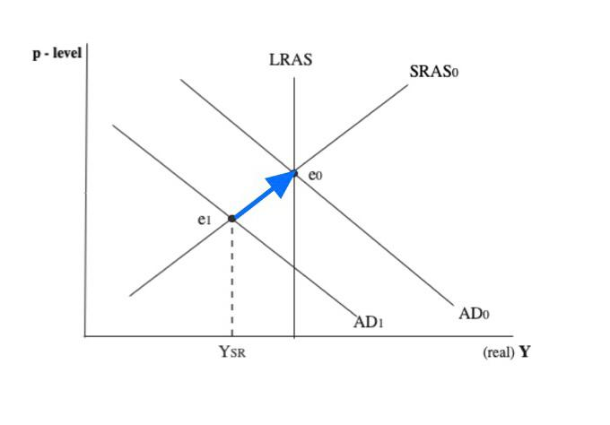

**f.**

Some economists advocate government intervention for the following two reason:

The Recession Length: Especially in deep recessions, the process needed to recover may be too slow and painful. Self-adjustment process needs several years but government intervention needs less time. It may take a long time for labor to accept the lesser nominal wage even if its purchasing power is increased.

Multiplier effect: When the government spending is to increase productivity and stimulate private consumption, it has a multiplier effect that all components of the aggregate demand is increase. Therefore, with small stimulating government spending, the economy can recover from the recession and back to its equilibrium level before the recession without strictly causing the crowding out effect.

**g.**

According to Keynesians, firms that are deep in recessions with excess capacity are eager to increase sales without price increases, thus, every extra demand will cause extra production. As additional demand does not cause a p-level increase, private spending does not need to be affected adversely. Since the level of investment is already in low levels, government spending may not crowd out private spending. In other words, if firms could not invest before government intervention, a higher interest rate caused by government spending does not have severe effects. Also, if government spending create confidence in economic agents, their spending will increase. Therefore, in deep recessions the multiplier effect will be big.

According to the classics, there is no use of government intervention if the output always back to potential level. The government intervention only create crowding out, p-level increase and increase debt. In classical model, crowding out is important since GDP decrease from potential is small. When the government spend some money on even stimulating programs, income and real GDP will increase. Therefore, the money demand and interest rate will increase. When interest rate increases, private expenditures will fall since households and firms takes less money to borrow. Net exports will also decline since higher interest rates will attract foreign investors to take more currency from this country and therefore, the exchange rate will increase. Therefore, the products of this country will become hard to sell in foreign markets since they become expensive. More products will be imported since they become cheaper. After all that, if the government decides to finish the stimulating program, then in addition to crowding out effect, there will be real GDP decrease which results in worser recession. Therefore, according to the classic view, it is best to just wait for self-adjustment process to recover from recession.

**h.**

In the Keynesian model, the multiplier is larger because the economy in deep recession and operating below its potential output level, the stimulating effect of the government spending is big on the private investment and consumption as it indicated in detail in part g. Therefore, smaller G increase in Keynesian model can correct the economy than Classical model. The fiscal multipliers can be defined as the amount of output increase with the given increase in government spending. As mentioned in part g, in deep recessions, the ratio of output and government spending become even to 1 to 1 but it will be much much smaller during expansions since the private expenditures are already growing and any government intervention may cause crowding out effect. Therefore, claim is correct.